The Teacher Coach
Becoming an Effective and Impactful Educator
Kendria R. Johnson M. Ed

Author, Teacher, Public Speaker, Coach, Business Owner

Life and Career
Ms. Johnson resonates from Dallas, Texas. She began her career teaching fourth grade Math and Science and it seem to “stick” to her and bring in a brand new focus for her career choice. Ms. Johnson has a strong passion for girls in STEM careers as she, herself, has been teaching Math and Science for over eighteen years. “I had a daughter that loved Math and my desire is to inspire that passion into someone else’s daughter.”

In August 2022, Kendria has dropped her new book Teacher of the Year which is an introduction to her TEACH 4 Life Mentor Program. This program will revolutionize the world of burnout teachers. It is a comprehensive program that develops stress management and life adaptation skills that is specifically designed for teachers by a teacher.

Public Speaker
Kendria Johnson began public speaking in 2013, as supplemental income for teaching . Working with teachers in the American Federation of Teachers gave her the boldness to position herself as a teacher trainer and educational consultant. Within this organization, she was trained hundreds of teachers, which gave her the title of a Teacher Training Teachers. She has held numerous workshops for adults and students. Recently Kendria has rekindled public speaking hosting events that develop her business and help teachers manage their classroom and their personal lives. She moved to United Arab Emirates in 2015 hoping to get a break from the stress-filled life that consumes teachers in public school education. Now she is ready to give back her 20 years for knowledge to someone else.
“I began to hate my job. Something I used to love so much began to drain the life force from my soul. I had to do something different. For the sake of my health, I had to make a drastic move.”

Kendria Johnson, M.Ed : Targets Teachers and Educational Professionals
In August 2022, Kendria has dropped her new book Teacher of the Year which is an introduction to her TEACH 4 Life Mentor Program. This program will revolutionize the world of burnout teachers.
“I help good teachers become
great by bringing them from burnout back to a balanced life.”
IG: @teacheroftheyear13
FB: @teacheroftheyear2020
LinkedIn: www.linkedin.com/in/kendria-johnson-a9634a173
Personal Website: www.iamkendria.com
Business :https://teach4life.training
Get your AudioBook NOW
Audiobook: https://www.teacherspayteachers.com/Store/Teachforlife-Program
Kindle/Ebook/Amazon Links
https://www.amazon.com/Teacher-Year-Strive-Thrive-Toolkit-ebook/dp/B0BBSBSLNF
Paperback
https://www.amazon.ae/Teacher-Year-Strive-Thrive-Toolkit/dp/1913434044/ref=sr_1_1?keywords=strive+to+thrive+toolkit&qid=1663769319&s=books&sr=1-1

#educator #teacher #teachersfollowteachers #mentalhealth #mentalhealthawareness #mentalhealthmatters #selfcare #stopteacherguilt #iteach #teacherlife #teacherstyle #teacherappreciation #edupreneur #educationmatters #education #schooladministrators #EdChat #burnoutprevention #teacherideas #teacherstressrelief #classroomideas #teacherprobs #teacherburnout

FREE Masterclass
https://teach4life.ewebinar.com/webinar/the-teach4life-solution-6081

Audiobook, Teacher of the Year
https://www.teacherspayteachers.com/Store/Teachforlife-Program

Kendria , The Teacher Coach. I help good teachers become great by bringing them out of burnout into a balanced life.
@teacheroftheyear13
Email: teach4life_training@outlook.com

https://youtu.be/WO4cTZaN8Wo

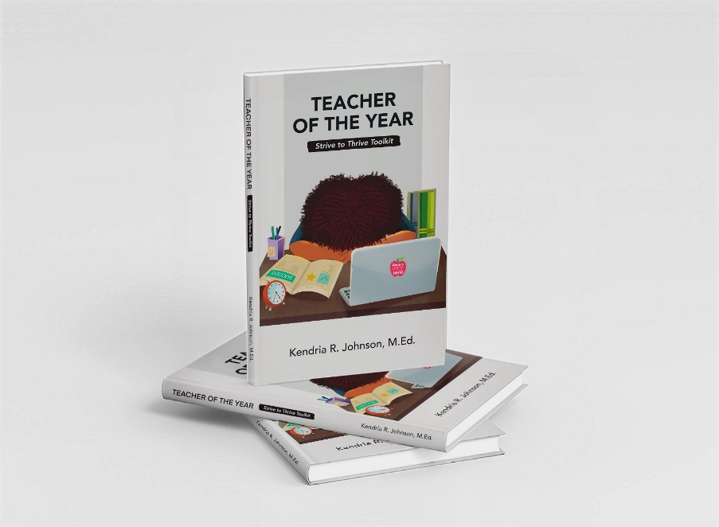

Photo Credit: Corey D’Ron Life Behind the Lens Photography
www.Coreydronmedia.com

